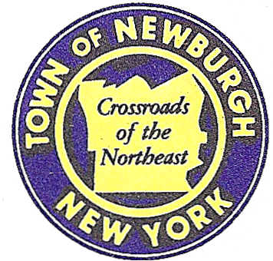

TOWN OF NEWBURGH
_______Crossroads of the Northeast __________________________
OLD TOWN HALL
308 GARDNERTOWN ROAD NEWBURGH, NEW YORK 12550

PLANNING BOARD
JOHN P. EWASUTYN, CHAIRMAN
TELEPHONE 845-564-7804
FAX 845-564-7802
E-MAIL: planningboard@townofnewburgh.org

PLANNING BOARD AGENDA

October 19th, 2017

*PLEASE NOTE: The Planning Board Meeting will start at 7:00 P.M. and all Applicants/Representatives
are to be present at that time. The Meeting will be held in the Meeting Room of Town Hall,
located at 1496 Route 300, Newburgh NY.*

- McDonalds (17-14) AMENDED SITE PLAN
1403 NY-300
Section 60, Block3, Lot 41.21
Zone:
Rep: Andrew Lee, Core States Group
6500 Chippewa St. Suite 200
St. Louis, MO 63109

2. WPA Acquisition (Gekakis) (17-24) INITIAL APPEARANCE
54 Jeanne Drive LOT LINE CHANGE
Section 34, Block 2, Lot 100 & 101
Zone: IB
Rep: Paul Berger, P.E.
100 Fulton Ave.
Poughkeepsie, NY 12603

3. Dominos Pizza (17- 25) INITIAL APPEARANCE
88 North Plank Road AMENDED SITE PLAN
Section 77, Block 27, Lot 2.1
Zone: B
Rep: Talcott Engineering Design, PLLC
1 Gardnertown Rd.
Newburgh, NY 12550

*WORK SESSION*
Project Readiness Discussion scheduled for 6:00 p.m. in the Meeting Room of
Town Hall on Thursday, October 19th, 2017.*

PLANNING BOARD BUSINESS
WORK SESSION

- Polo Club (06-09) - 6 month extension: October 19, 2017- April 19, 2018.

*WORK SESSION*
Project Readiness Discussion scheduled for 6:00 p.m. in the Meeting Room of
Town Hall on Thursday, October 19th, 2017.*

